**Task 1.2 (SQL-Oracle)**

**Stage 2:**

*Assumption-Mandatory KYC documents for business loans are Aadhar card and PAN card (Mobile number already linked with Aadhar card) but due to no such records found with respect to the given queries, it has been assumed that mobile number is mandatory KYC document along with any one of the other five documents.*

**Query 1-**

* Generate Reports of the customer who has approached for the loan and all KYC is submitted and disbursal date is not given, or loan is not disbursed.

*Case 1- If all KYC documents are submitted i.e., all 6 flags=1*

SELECT *

FROM Loan_details

WHERE (mobileno_avl_flag = 1

AND aadhar_flag = 1

AND pan_flag = 1

AND voterid_flag = 1

AND driving_flag = 1

AND passport_flag = 1

AND (disbursaldate IS NULL OR disbursed_amount = 0));

*Output-*

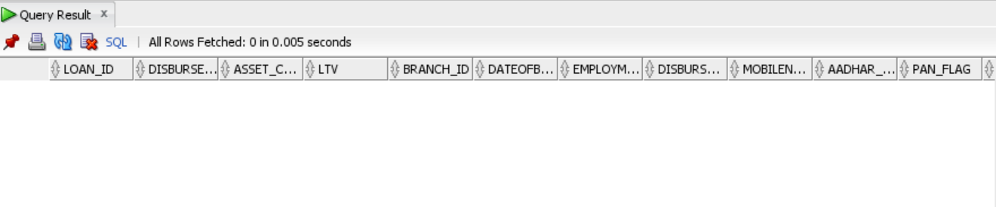

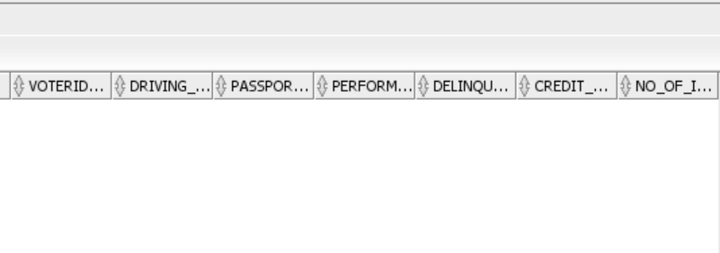

*Conclusion- As per the above output, it can be concluded that there are no such customers who have submitted all the KYC documents. So, we consider case 2.*

*Case 2- If mobile number is submitted along with any one of the other five documents.*

SELECT *

FROM Loan_details

WHERE (mobileno_avl_flag = 1

AND (aadhar_flag = 1

OR pan_flag = 1

OR voterid_flag = 1

OR driving_flag = 1

OR passport_flag = 1)

AND (disbursaldate IS NULL OR disbursed_amount = 0));

*Output-*





*Conclusion- As per the above output, it can be concluded that there are no such customers for whom the disbursal date is not given, or the loan is not disbursed.*

**Query 2-**

* Generate Reports of the customer who has approached for the loan whose Bureau Score is less than 650 and min. inquires made is >3 and the cost of asset is between 50000 to 70000 and LTV is between the range of 50-60.

SELECT *

FROM Loan_details

WHERE perform_cns_score < 650

AND no_of_inquiries > 3

AND (asset_cost BETWEEN 50000 AND 70000)

AND (ltv BETWEEN 50 AND 60);

*Output-*

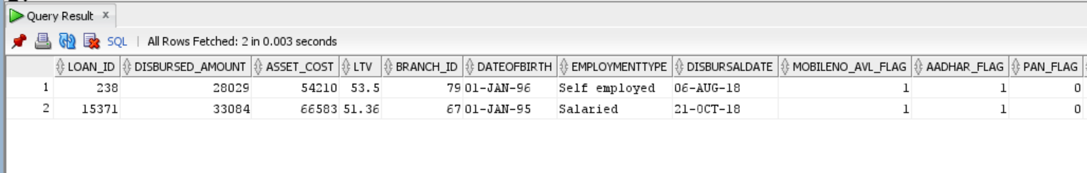

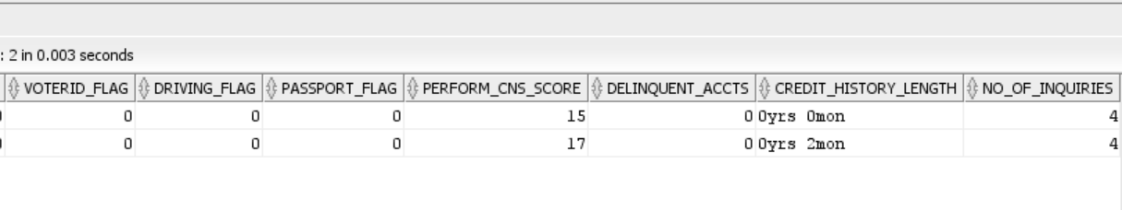

*Conclusion- From the above result, it can be concluded that there are 2 customers who satisfy the aforesaid conditions.*

**Query 3-**

* Generate Reports of the customer who has approached for the loan whose Bureau Score is less than 650 and min. enquires made is >3 and the cost of asset is between 50000 to 70000 and LTV is between the range of 50-60.

*Same as query 2*

**Query 4-**

* Generate Reports of the self-employed customer who has approached for the loan whose Bureau Score is less than 650 and min. enquires made is >3 and loan default are 0 and if all KYC is submitted and cross checked if any dues to previous loans.

*Case 1- If all KYC documents are submitted i.e., all 6 flags=1*

SELECT *

FROM Loan_details ld

INNER JOIN Loan_status ls

ON ld.Loan_id = ls.Loan_id

WHERE (ld.employmenttype = 'Self employed'

AND ld.perform_cns_score < 650

AND ld.no_of_inquiries > 3

AND ls.loan_default = 0

AND ld.mobileno_avl_flag = 1

AND ld.aadhar_flag = 1

AND ld.pan_flag = 1

AND ld.voterid_flag = 1

AND ld.driving_flag = 1

AND ld.passport_flag = 1

AND ld.delinquent_accts>0);

*Output-*

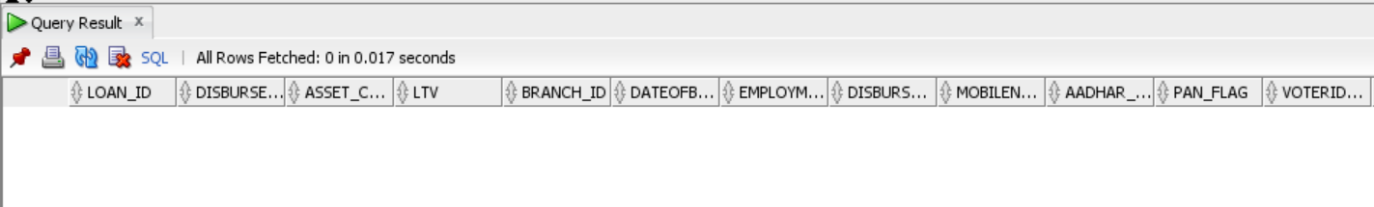

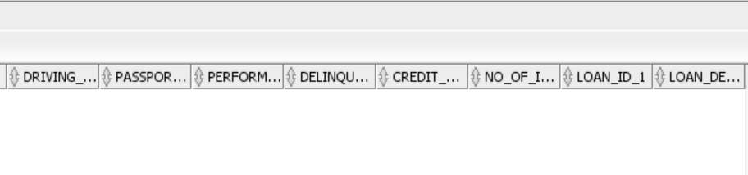

*Conclusion- As per the above output, it can be concluded that there are no such customers who have submitted all the KYC documents. So, we consider case 2.*

*Case 2- If mobile number is submitted along with any one of the other five documents.*

SELECT *

FROM Loan_details ld

INNER JOIN Loan_status ls

ON ld.Loan_id = ls.Loan_id

WHERE (ld.employmenttype = 'Self employed'

AND ld.perform_cns_score < 650

AND ld.no_of_inquiries > 3

AND ls.loan_default = 0

AND ld.mobileno_avl_flag = 1

AND (ld.aadhar_flag = 1

OR ld.pan_flag = 1

OR ld.voterid_flag = 1

OR ld.driving_flag = 1

OR ld.passport_flag = 1)

AND ld.delinquent_accts>0);

*Output-*

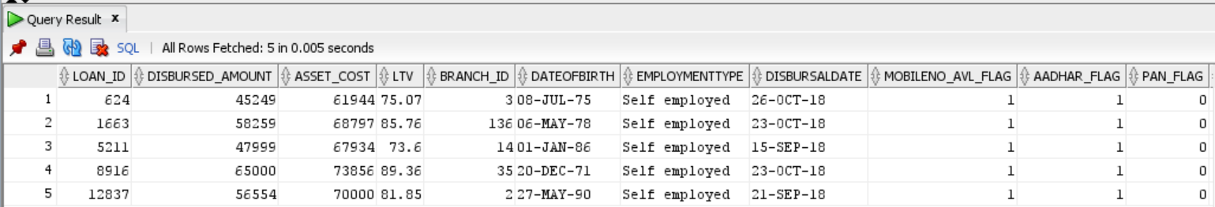

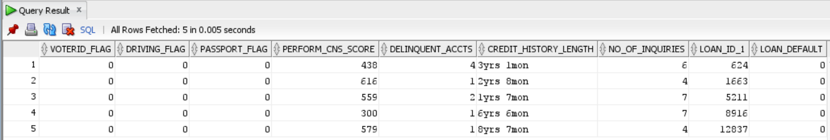

*Conclusion- From the above query result, it can be deduced that there are 5 such customers who have submitted the mobile number and Aadhar card as KYC documents and fulfil all the other mentioned constraints.*

**Query 5-**

* Generate Reports of those customers where the loan is disbursed based on the Cibil score ranging between 670 -780 and also who are acquired the loan for more than 1 time and loan default is 1 or 0.

SELECT *

FROM Loan_details ld

INNER JOIN Loan_status ls

ON ld.loan_id = ls.loan_id

WHERE ((ld.disbursed_amount>0 OR ld.disbursaldate IS NOT NULL)

AND (ld.perform_cns_score BETWEEN 670 and 780)

AND ld.delinquent_accts>0

AND ls.loan_default IN (0, 1));

*Output-*

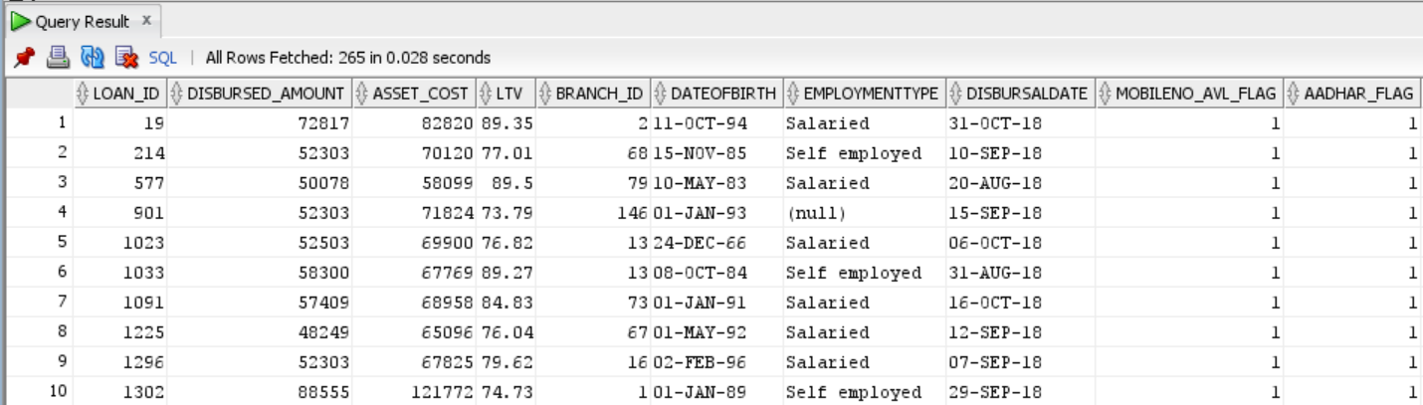

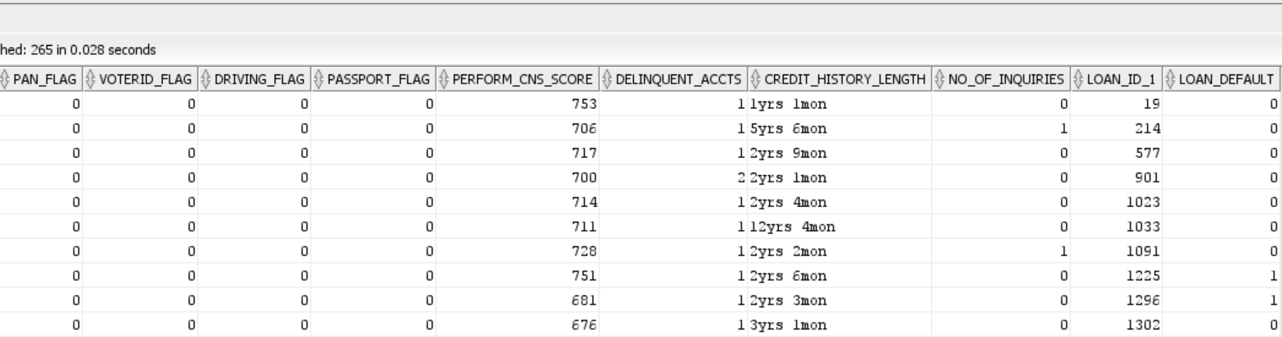

*Conclusion- The above query returns 265 records which meet the above stated requirements.*